Stone Cold
Technical & Design 14-17
Set Design

Tasks designed to help students work out how they would stage scenes from Stone Cold

What do I have to do on staging in the examination?

Question 4 of the written exam asks you how you would stage a section of the play. You have to draw a labelled groundplan of your set design [as if looking down from above].

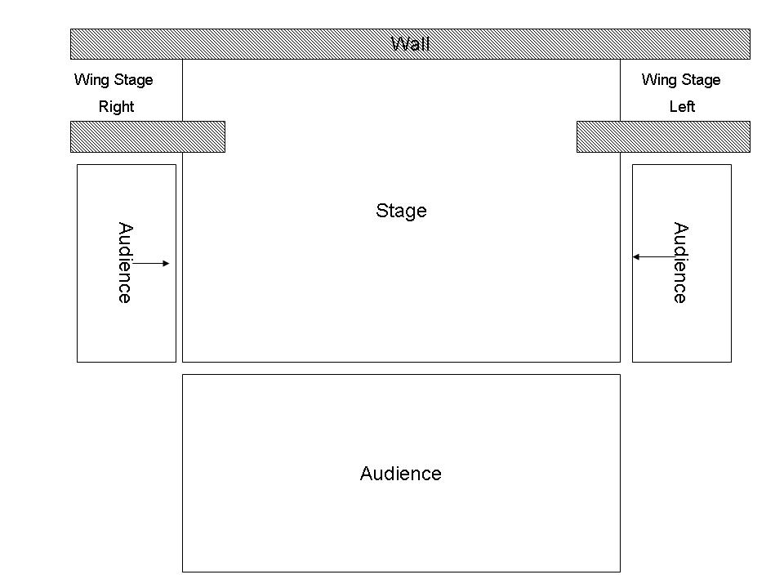

You then have to explain and justify your ideas in detail, commenting on:
- the set you have created [what, where, why?]
- the choice of colours used
- the production style
- the atmosphere

Getting Started

How do I stage the scene/extract?
The first thing you need to do after reading the given section of the play is to look at the functional demands of the action. In other words, work out what is actually needed on stage in that extract. This will give you the bare essentials you need.

Positioning the audience
You then need to decide which type of audience positioning you consider to be most appropriate. Try to work out some reasons why.

At this time you will be better off sticking to the most commonly used types which are:
- End-On/ Proscenium Arch [audience in front]
- Theatre in the Round [audience all the way around]
- Thrust Staging [audience on three sides]
- Traverse Staging [audience on two opposite sides]

Whichever type of audience positioning you choose will have a huge effect on the set, particularly regarding using different levels, painted scenery, projections or large items of furniture. Audience sightlines always need to be a top priority so choose carefully.

Remember: there will always be problems which need solving!

How else can I create atmosphere?
Now that you have worked out what you need on stage and chosen your audience position, you need to consider whether there are any extra ways of creating atmosphere or reinforcing the themes of the extract. Also think about how lighting, sound, projections and costume can play a part in working with your set design ideas.

Specific issues with Stone Cold

There are some very specific problems to solve with staging Stone Cold.
- The play consists of a great many short scenes so it would be virtually impossible to have big scene changes between each one.
- So many different locations are used. The dramatic action takes us from the streets, to a newspaper office, to a station, to a boat, to a café- to name a few examples.
- You will almost certainly need a permanent area for Shelter’s apartment as the action constantly switches between Link and Shelter in his flat.
- There are suggestions in the script that projections are used, though of course you do not have to use them.
- A window is referred to several times in Shelter’s apartment.

Designing a set for Stone Cold

When you take all these factors into account it soon becomes clear that a minimalistic style is probably necessary. You need to find simple, quick and effective ways of suggesting the different locations and the different times involved. It may be worth considering using a raised level for Shelter’s apartment, particularly if you want to use a trap door as referred to in the final scene. The rest of the acting area can then be used for all the other scenes. If you are using a projection screen it would probably be best to use End-On or Thrust staging. There are also several other items which you may also want to use as permanent fixtures as they are used several times such as
- A telephone booth
- An entrance/alcove
- 2 or 3 dustbins
- A projection screen

Task 14
The groundplan for Shelter’s flat

Design a groundplan of Shelter’s flat.

You may wish to include:
➔ as outlined in Scene 1- his armchair, a doorway to the
kitchen, a window, his dictaphone and a portrait of a soldier.
➔ the trapdoor he hides his victims under.

Task 15

Different Locations

More than 15 other locations are referred to in the play where scenes take place.

Make a list of them.
Beside each location on your list, write down two items or pieces of ‘stage furniture’ that would best help to suggest each of these settings.
You may in addition wish to suggest your ideas for a projected image that could be shown for each scene.

Task 16

Designing a groundplan for the whole play

Now that you have thought about Shelter’s flat and all the other locations, design a groundplan that would work for the whole play, involving as little shifting of scenery as possible. You may wish to consider using the items referred to in the section ‘Designing a set for Stone Cold’ as ‘permanent fixtures’ as they are used so often and then bringing on one or two items to suggest each of the other scenes.

Task 17

Staging two of the hardest scenes

Work out how you would stage each of the following scenes and draw a groundplan for each one. You may find that it helps to try acting them out first.

Act 1 Scene 16
The problem: Link goes from outside a boat to inside a boat, then there’s a flashback of scenes from Link’s past, then there is a fantasy sequence where Link dreams he is staying in a luxury Hawaiian hotel.

Act 1 Scene 12
The problem: Link starts in a doorway at Caring Cross station, then he jumps over a turnstile to go to the toilet; he escapes from the attendant, does a lap of honour, then returns to his doorway to find Scouse who steals his watch. Images are then ‘projected onto three screens around the stage’ with a Phil Collins backing track.

